Welcome to Lamoille Valley Bike Tours!
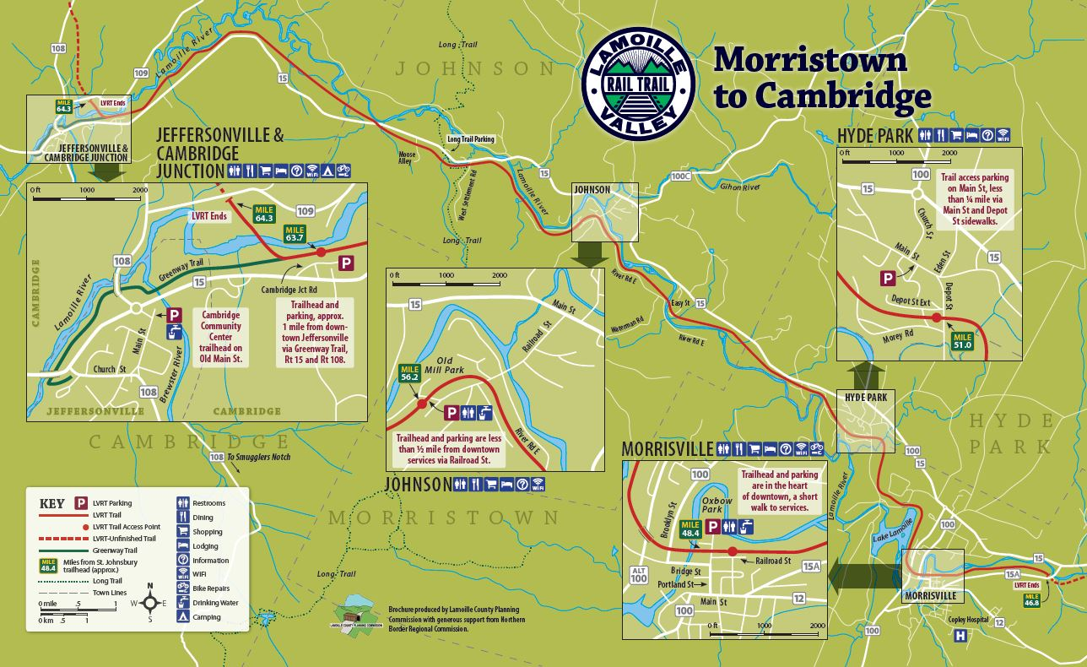
Operating on the Lamoille Valley Rail Trail since 2016! Constructed in the 1870s the St. Johnsbury and Lamoille County railroad was designed to connect the Great Lakes with the seaport of Portland, Maine. The western connection was never made but for over 100 years the Lamoille Valley Rail Road was a major east west route for people and goods to travel across the northern part of the state and New England. The Railroad brought outside goods to the state and helped transport dairy, forest, and textile products (think wool) from Vermont to the rest of country. The railroad supported the blue-collar manufacturing industries along its path and contributed to the history of development in northern Vermont. The trains stopped carrying passengers in the 1950’s and stopped running for good in the mid 1990’s. The rail corridor sat vacant for over 20 years…
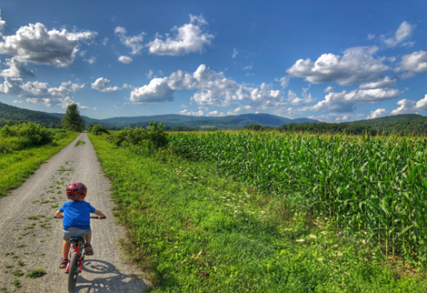
Following years of planning and effort, the conversion of the Railroad to the Lamoille Valley Rail Trail came to life in 2016. Two segments of trail, Cambridge to Morrisville and Danville to St. Johnsbury, opened to the recreational public. The segment between Swanton and Sheldon followed in 2019, and finally in December of 2022 the entirety of the trail opened. Thanks to a collaboration between the Vermont Agency of Transportation, Vermont Association of Snow Travelers and good old private citizens, not only do Vermonters have the luxury to view and enjoy these lost and forgotten sights but can take pride in showcasing this fresh and authentic countryside to travelers across the country. The Lamoille Valley Rail Trail is the longest four-season recreational trail in New England at 93 miles. The trail of compacted crushed stone surface connects eighteen communities in five counties and some of Vermont’s most breathtaking scenery, diverse landscapes of field, working farmland, mountains, and wetlands. The trail provides a safe and scenic alternative travel corridor that encourages you to not only view authentic Vermont in all its glory, but to slow down and experience it! Highlighting stretches of sleepy cow farmlands, high cornfields, winding rivers and rolling mountain scenery, the trail sports shopping, breweries, and restaurants and takes you through a handful of quaint villages for a chance to eat, explore, swim and take in the local art and history of the Green Mountain State. This guide covers the busiest and most developed stretch of trail which offers a host of amenities. The information contained in this guide is focused on what’s available within a day’s ride from our headquarters in Johnson.
Traveling WEST from Johnson (LVBT)
Distance To Cambridge Trailhead: 8 Miles
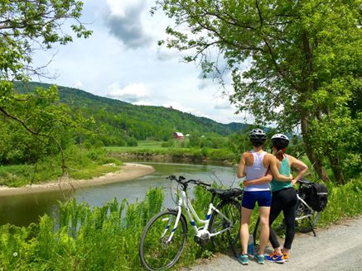
Distance to Village of Jeffersonville: 9 Miles
Without a doubt this direction from our trailside headquarters is one of the most scenic stretches of the LVRT! Whether it’s the working farm landscape, sweeping fields of flowers, beautiful and wild river plain, or the breathtaking mountainous scenery this jaunt is a hit! You’ll have plenty of opportunities for picnicking and photo ops along the way as the trail follows the winding Lamoille River along most of its path. Keep an eye out for footpaths down to the water where you can find your own picnic spot or private beach. The rail trail also provides access to clothing and recreational shops along the way. Check out the Red Barn and Johnson Farm and Garden just outside the village of Johnson to the west. Once you pass the big road crossing, you’ll enjoy long views of the sweeping valley and some great scenic photo opportunities.
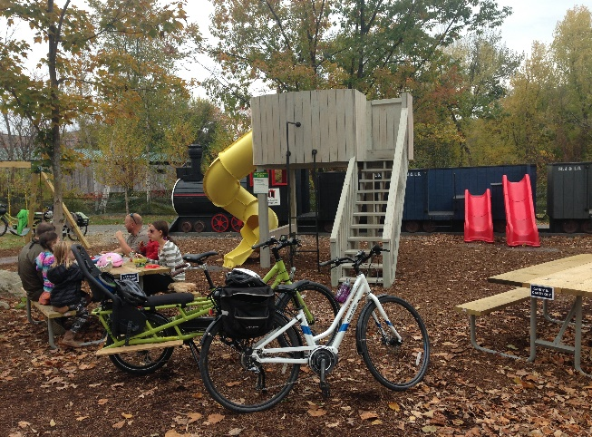
After 30-40 minutes of riding, you’ll arrive in Jeffersonville at the Cambridge Jct. trailhead. Kids (and adults) will delight in the quaint railroad themed playground. Complete with a bathroom, drinking water and a scenic historic covered bridge the trailhead is a great place to stop for a break or for lunch. Here the LVRT merges with the Cambridge Greenway Trail before continuing west. We highly recommend you follow the signs to the Cambridge Greenway Trail and pedal another ¾ of a mile into the village of Jeffersonville, gateway to Smuggler’s Notch. Here you can enjoy a variety of delicious foods, beverages, art, and recreation. There are two ways to get to the village from the trail…when you get to the wooden bridge along the trail you’ll notice a parking area and set of wooden stairs leading down from the trail. Here is where you would cross Route 15 if you want to head into the Village. With your bike crossing safely walk across the roadway finding the path on the other side. You can also choose to follow the Greenway Trail along the river to the end of the trail on the other side of town and access the village behind Jana’s Cupboard & Deli.
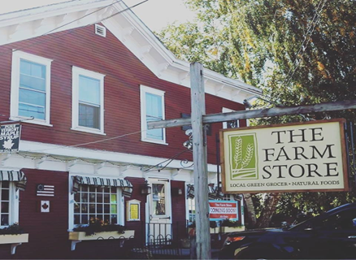
Once in Jeffersonville be sure to check out Smuggler’s Notch Distillery located right off VT Route 15 and the Greenway Trail and sample their award winning liquor products and maple syrup before heading into the village for some great food, country shops and thriving art scene. The beautifully painted silos across the street depicting seasonal images of the town’s past and future are a must see!
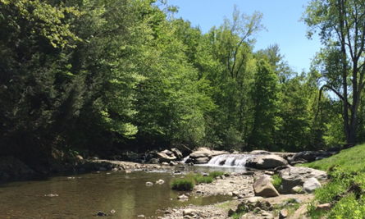
On hot days, Jeffersonville is a great place to cool off in a number of swimming holes! From the center of town follow the Brewster River and Route 108 slightly uphill ¼ mile to Jeff Falls (look for small parking area just off roadside on left). A large pool and set of falls is located slightly upstream following a footpath into the woods. Another great spot for lunch or to cool off lies just another ¼ mile up Route 108. Ride safely uphill along Route 108 to Canyon Road. Follow the road to the covered bridge and Brewster River Park. A nice swimming hole, set of falls and neighborhood beach all make for a great place to cool off under the backdrop of the covered bridge!
Additional food and attractions
158 Main - 158 Main, 158 S Vt 108
Burger Barn - 4968 Vt Rt. 15
Brewster River Pub and Brewery - 4087 Vt Rt. 15 South
Martell’s at the Red Fox - 87 Edwards Rd.
The Village Tavern - 55 Church St
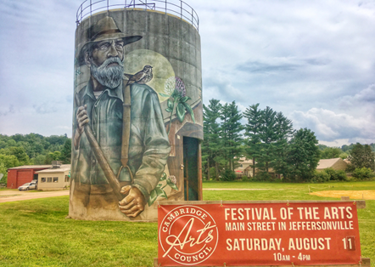
Hanley’s General Store - 30 S Vermont 108
Jana’s Cupboard and Deli – 4837 VT-15
Vermont Canoe and Kayak - 4805 VT-15
Bryan Memorial Gallery - 180 S Vermont 108
Brewster River Swimming Hole – Rt. 108

Biking West Beyond Jeffersonville….
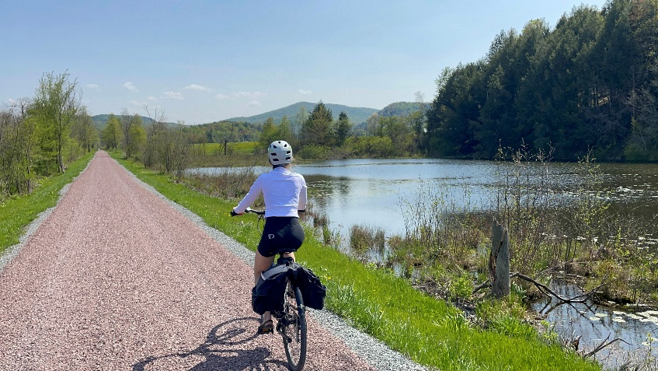
Distance To Town of Fairfield: 10 Miles (from Jeffersonville)
For those participating in our Full Day Adventure Tour, you will have the opportunity to enjoy both this quaint resort village and travel further on through Cambridge toward the town of Fletcher, through valleys of rolling farm fields and serene, picturesque wetlands. Look out for native birds and wildlife. This area is a great place for birding and picnicking and very different from the first stretch of trail from Johnson to Cambridge. Rural in nature, be sure to gear up before your head our beyond Jeffersonville it’s 10 miles to the nearest town (Fairfield) which has a small convenience store. See how much you can take in before heading back to enjoy the views of Vermont’s highest peaks toward Cambridge and then Johnson!

Heading EAST from LVBT (Johnson)
Distance To Hyde Park Village & Trailhead: 5 Miles (from Johnson)
Distance to Morrisville: 8 Miles (from Johnson)
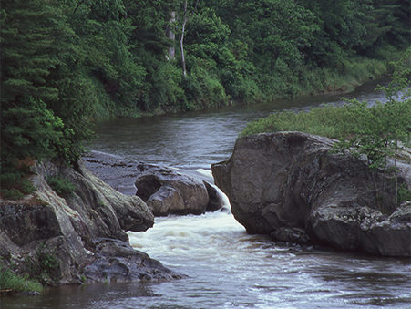
Head east from Johnson through shady forests, breezy wide-open fields and over the winding river with Elmore Mountain as your back drop through Hyde Park to Morrisville, the business and social hub of the county. On your way out of Johnson you will pass by a popular landmark and geologic feature on your left known as Dog’s Head Falls: The river narrows and drops about 8 feet into a slim gorge. Look for the rock formation resembling a dog. Do you see it?
Soon after you’ll cross an old iron bridge placing you on the north side of the Lamoille River for the rest of your journey. After passing through keep an eye out for our friends at the VT Flannel Company or grab some grab at the Maple Hill Barn. Enter through the farm fields tractor path (look for sign) on your left and the flannel folks are just on the other side of the VT Route 15.
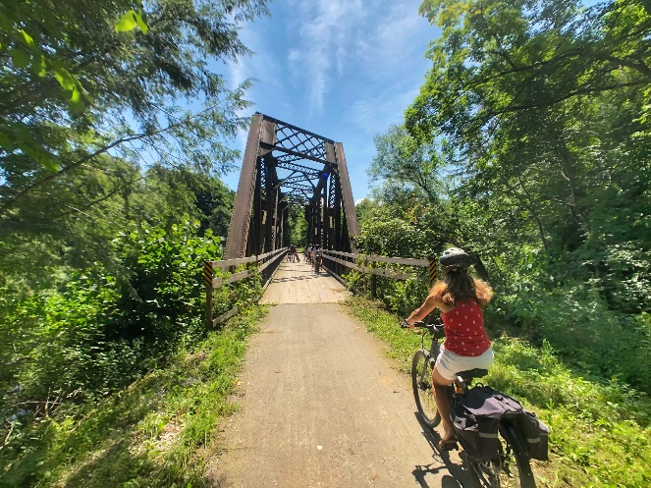
Soon after you’ll come to the Village of Hyde Park. This county seat and historical hub has retained most of its New England architectural character and is worth the short ride up the hill from the rail trail (follow the signs to the Village from Black Farm Road). Enjoy a meal or coffee at Two Sons Bakehouse or explore the Hyde Park history trail and visit the historic Hyde Park Opera House still putting on shows today!
As you approach Morrisville the grade steepens, and you begin to get a bird's eye view of the landscape. Keep on the lookout for remnants of an old train car derailment while taking in the views of iconic bridges on this old rail corridor.
​Naturally when you ride for a good part of the day food is on your mind. Morrisville provides plenty of food and dining options and is a great place to plan a half day lunch tour. The town is also becoming one of the most bike friendly towns in Vermont so feel free to explore what this village has to offer. Visit any of the many restaurants throughout the village including Lost Nation Brewery, which offers great food along with award winning beer, and 10 Railroad Street, a restaurant built in a historic renovated train station. Both are located directly on the trail! There are some great shops to browse through right in the village too. You can also grab a picnic lunch at any of these fine eateries to enjoy on the trail or in the picturesque Oxbow Park.

Additional Food and Attractions
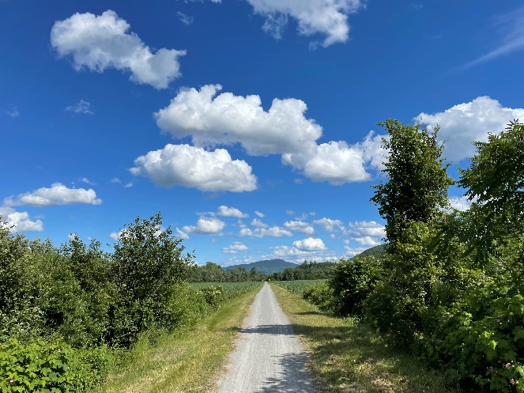
Ten Railroad Street Restaurant - 10 Railroad St.
Moogs Place Restaurant - 97 Portland St.
Pizza On Main - 53 Lower Main St.
Siam Valley Thai - 387 Brooklyn St.
Thompson's Flour Shop - 84 Lower Main St.
The Oasis Cafe - 82 Lower Main St.
Lost Nation Restaurant and Brewery - 87 Creamery Rd.
Rock Art Brewery - 632 Laporte Rd.
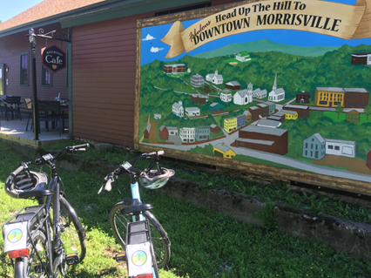
Moss Boutique - 85 Portland St.
Noyes House Museum - 122 Lower Main St.
River Arts - 74 Pleasant St.
Morrisville Food Coop - 46 Pleasant St.
Morrisville History Walk - Park St, Portland St, Main St.
Oxbow Park - 257 Portland St.

Biking East Beyond Morrisville…
Distance To Town of Wolcott Trailhead: 8 Miles (From Morrisville)
Distance to Town of Hardwick: 14 Miles (From Morrisville)
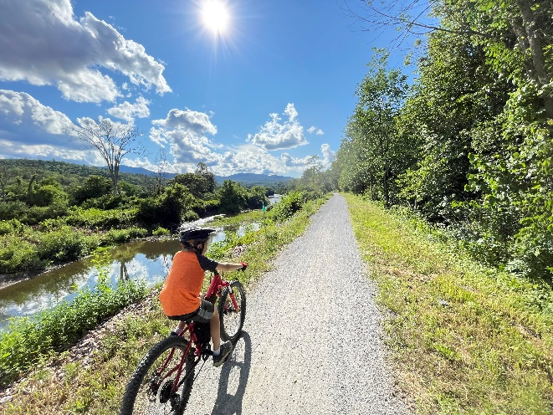
For those participating in our Full Day Adventure Tour, you will have the opportunity to enjoy stocking up in busy Morrisville village with lots of shopping, art and dining opportunities and travel further on parallel with the Lamoille River for the greatest river views on the entire 93 mile trail to the town of Wolcott. Enjoy the scenic beauty of the wild river basin, attractive fishing pools and miles of smooth biking over several charming bridges along the way. Take a cycling break in the quaint town of Wolcott enjoy their community garden with a park and benches right near the trailhead kiosk with restroom! If you have time, continue beyond Wolcott through shady, forested scenery toward the town of Hardwick, packed with local Vermont cuisine right on a bustling village Main Street. Soak in the artistic flavor of the town and food before heading back on your return ride!

